List_item.xml (To create this app→ res→ layout→ right click→ New→ Layout Resource file →

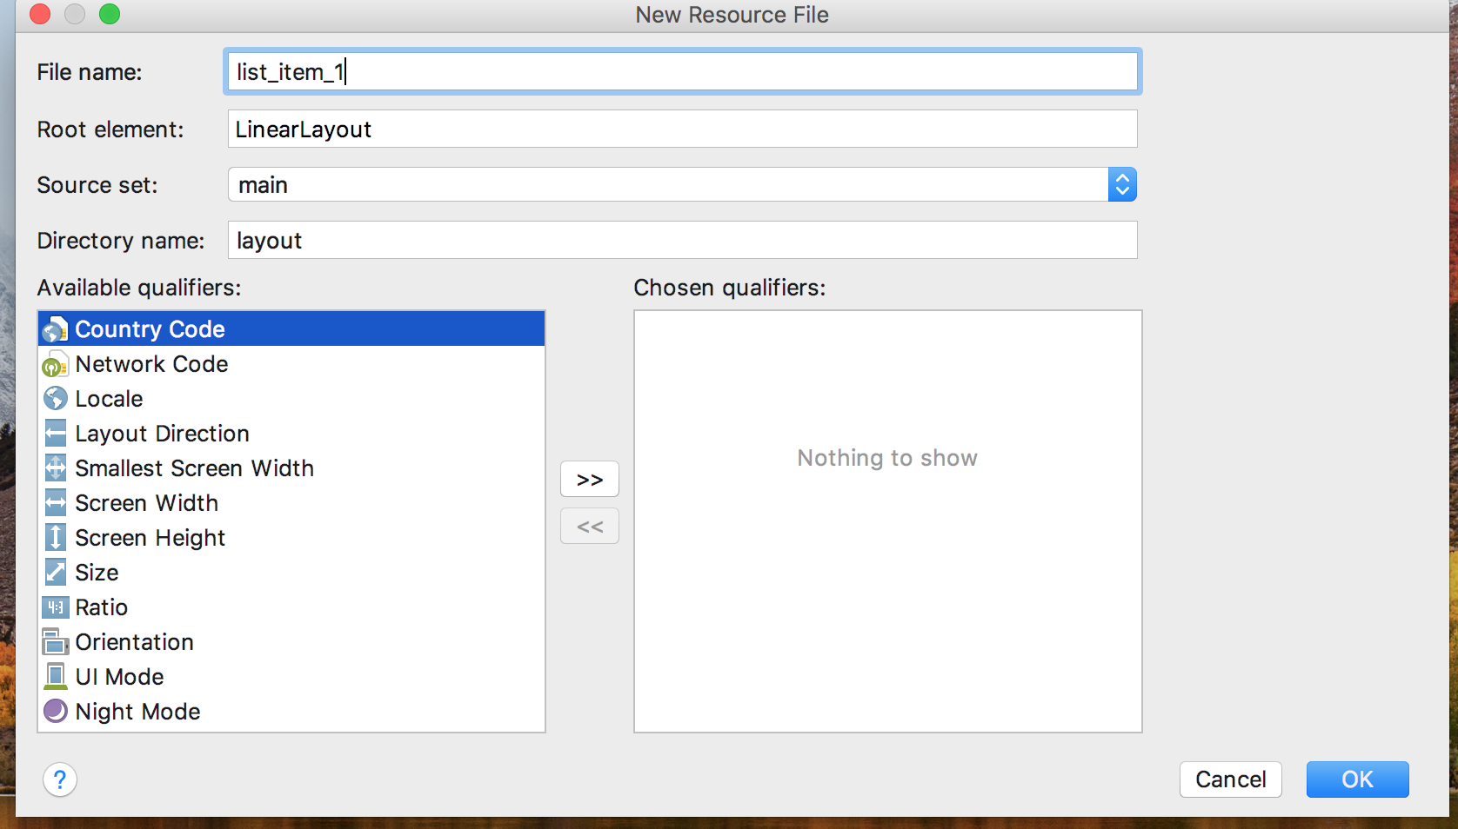

→ click OK

List_item.xml

*<?***xml version="1.0" encoding="utf-8"***?>*

<**LinearLayout**

**xmlns:android="http://schemas.android.com/apk/res/android"**

**android:layout_width="match_parent"**

**android:layout_height="match_parent"**

**android:orientation="vertical"**>

*<!-- dp /dip - Density-independent Pixels - an abstract unit that is based on the physical density of the screen.*

*These units are relative to a 160 dpi screen, so one dp is one pixel on a 160 dpi screen -->*

<**TextView android:id="@+id/product_name"**

**android:layout_width="fill_parent"**

**android:layout_height="wrap_content"**

**android:padding="10dp"**

**android:textSize="16dp"**

**android:textStyle="bold"**

**android:textColor="@color/colorAccent"**/>

</**LinearLayout**>

Activity_main.xml

*<?***xml version="1.0" encoding="utf-8"***?>*

<**RelativeLayout xmlns:android="http://schemas.android.com/apk/res/android"**

**xmlns:app="http://schemas.android.com/apk/res-auto"**

**xmlns:tools="http://schemas.android.com/tools"**

**android:layout_width="match_parent"**

**android:layout_height="match_parent"**

**tools:context=".MainActivity"**>

<**EditText**

**android:layout_width="wrap_content"**

**android:layout_height="wrap_content"**

**android:id="@+id/editText"**

**android:inputType="text"**

**android:hint="Type a fruit name"**

**android:maxLength="50"**

**android:layout_marginLeft="10dp"**

/>

<**ListView**

**android:layout_width="wrap_content"**

**android:layout_height="wrap_content"**

**android:id="@+id/listView"**

**android:layout_below="@id/editText"**

**android:layout_marginLeft="10dp"**

/>

</**RelativeLayout**>

MainActivity.java

**package** com.example.jevitha.a5_edittext_listview;

**import** android.support.v7.app.AppCompatActivity;

**import** android.os.Bundle;

**import** android.text.Editable;

**import** android.text.TextWatcher;

**import** android.view.View;

**import** android.widget.AdapterView;

**import** android.widget.ArrayAdapter;

**import** android.widget.EditText;

**import** android.widget.ListView;

**import** android.widget.Toast;

**public class** MainActivity **extends** AppCompatActivity {

**private** ListView **lv**;

**private** EditText **editText**;

**private** ArrayAdapter<String> **adapter**;

**private** String **products**[] = {**"Apple"**, **"Banana"**, **"Pinapple"**, **"Orange"**, **"Papaya"**, **"Melon"**,

**"Grapes"**, **"Water Melon"**, **"Lychee"**, **"Guava"**, **"Mango"**, **"Kivi"**};

@Override

**protected void** onCreate(Bundle savedInstanceState) {

**super**.onCreate(savedInstanceState);

setContentView(R.layout.***activity_main***);

**lv** = (ListView) findViewById(R.id.***listView***);

**editText** = (EditText) findViewById(R.id.***editText***);

**adapter** = **new** ArrayAdapter<String>(**this**,R.layout.***list_item***, R.id.***product_name***,**products**);

**lv**.setAdapter(**adapter**);

**editText**.addTextChangedListener(**new** TextWatcher() {

@Override

**public void** onTextChanged(CharSequence cs, **int** arg1, **int** arg2, **int** arg3) {

**adapter**.getFilter().filter(cs);

}

@Override

**public void** beforeTextChanged(CharSequence arg0, **int** arg1, **int** arg2, **int** arg3) {

Toast.*makeText*(getApplicationContext(), **"before text change"**, Toast.***LENGTH_LONG***).show();

}

@Override

**public void** afterTextChanged(Editable arg0) {

Toast.*makeText*(getApplicationContext(), **"after text change"**, Toast.***LENGTH_LONG***).show();

}

});

**lv**.setOnItemClickListener(**new** AdapterView.OnItemClickListener() {

@Override

**public void** onItemClick(AdapterView<?> adapterView, View view, **int** position, **long** l) {

String value=**adapter**.getItem(position);

Toast.*makeText*(getApplicationContext(),value,Toast.***LENGTH_SHORT***).show();

**editText**.setText(value);

}

});

}

}